6.7 User Guide

Blue Prism and Power Platform Integration

Document Revision 2.0

# Trademarks and copyrights

The information contained in this document is the proprietary and confidential information of Blue Prism Limited and should not be disclosed to a third party without the written consent of an authorised Blue Prism representative. No part of this document may be reproduced or transmitted in any form or by any means, electronic or mechanical, including photocopying without the written permission of Blue Prism Limited.

**© Blue Prism Limited, 2001 – 2020**®Blue Prism is a registered trademark of Blue Prism Limited

All trademarks are hereby acknowledged and are used to the benefit of their respective owners.  
Blue Prism is not responsible for the content of external websites referenced by this document.

Blue Prism Limited, 2 Cinnamon Park, Crab Lane, Warrington, WA2 0XP, United Kingdom  
Registered in England: Reg. No. 4260035. Tel: +44 870 879 3000. Web: www.blueprism.com

# Contents

Trademarks and copyrights 2

Contents 3

Introduction 4

Power Platform to Blue Prism Integration 5

Blue Prism process exposed as SOAP Web Service 5

Azure Function for REST Services 7

Blue Prism Custom Connector 11

Microsoft Power Automate Business Process 16

# Introduction

This document outlines the integration and configuration of Blue Prism and the Microsoft Power Platform which includes Power BI, Microsoft Power Automate and PowerApps.

Power Platform allows business users to standardize and automate processes in their organization through the creation of BPFs that can include 3rd party applications.  This is extremely powerful, but somewhat limited in scope as it can only be done in a cost effective “no code” fashion in environments where all applications offer existing connectors within the Power Platform or public APIs.

This document assumes a general understanding of Blue Prism Processes as well as Microsoft Flow.

Details on the Power Platform can be found here: [https://powerplatform.microsoft.com](https://powerplatform.microsoft.com/)

Requirements include:

* Blue Prism Software
* Microsoft Power Automate account
* Microsoft Azure account and ability to publish Azure functions from Visual Studio

# Power Platform to Blue Prism Integration

Components of the Solution

* Blue Prism Process exposed as SOAP Web Service
* Azure Function for REST Services
* Blue Prism Custom Connector
* Microsoft Power Automate Business Process

## Blue Prism process exposed as SOAP Web Service

Expose the Blue Prism process as a SOAP Web Service.

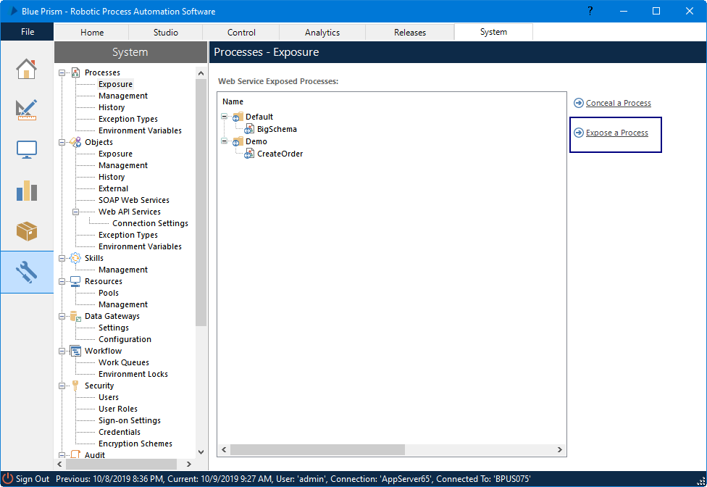

Make sure that you specify Document/literal encoding.

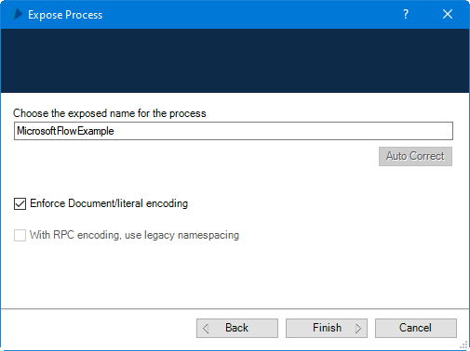

You can test to make sure the SOAP service is available by using the URL in a browser window:

http://<<machinename>>:<<resource agent port>>/ws/

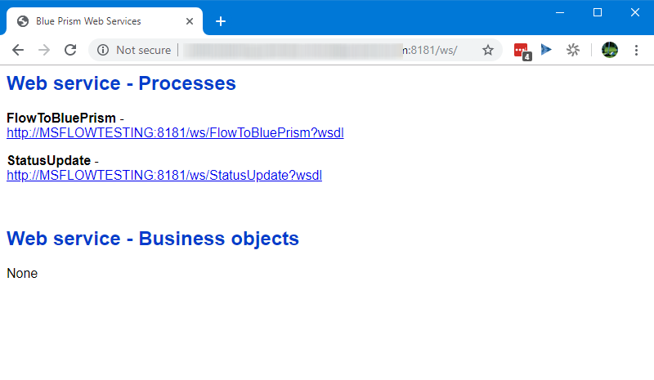

## Azure Function for REST Services

The Azure Function is provided as a Visual Studio project here:

<https://github.com/blue-prism/MicrosoftFlowAzureFunction>_v2

In depth tutorials on loading projects from GitHub repos can be found here:

<https://docs.microsoft.com/en-us/visualstudio/get-started/tutorial-open-project-from-repo?view=vs-2019>

Open the solution in Visual Studio and publish the Azure Function. You will need to specify your own Azure Function name. In depth tutorials on publishing to Azure from Visual Studio can be found here:

<https://docs.microsoft.com/en-us/azure/azure-functions/functions-create-your-first-function-visual-studio>

Create a publishing for Azure

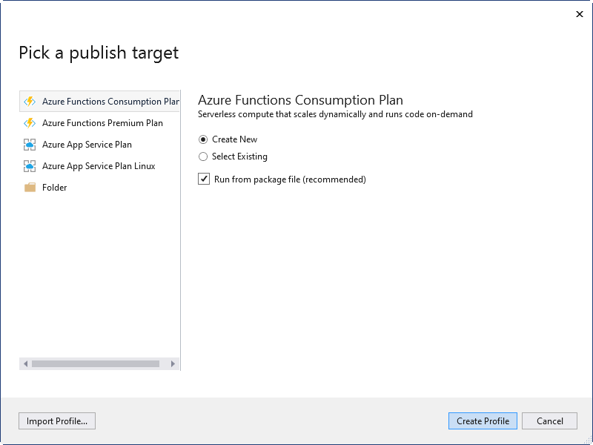

Provide the details for your Azure environment

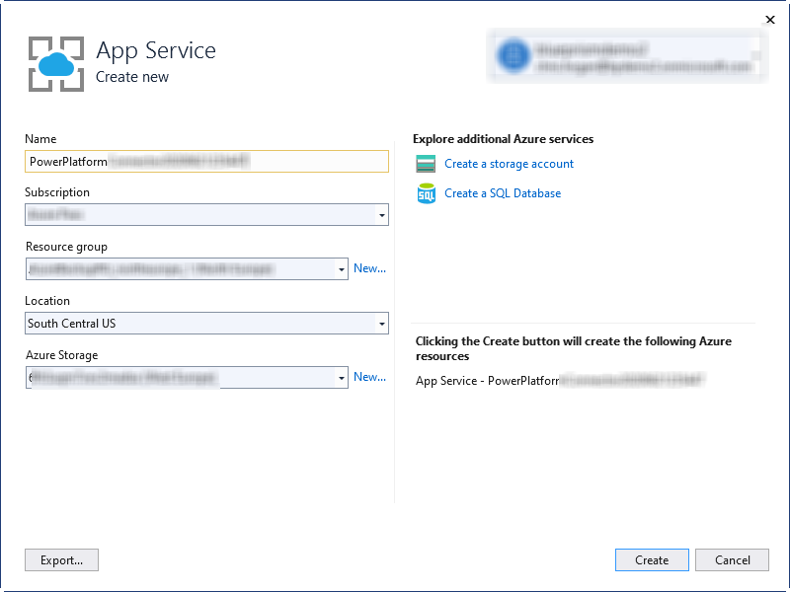

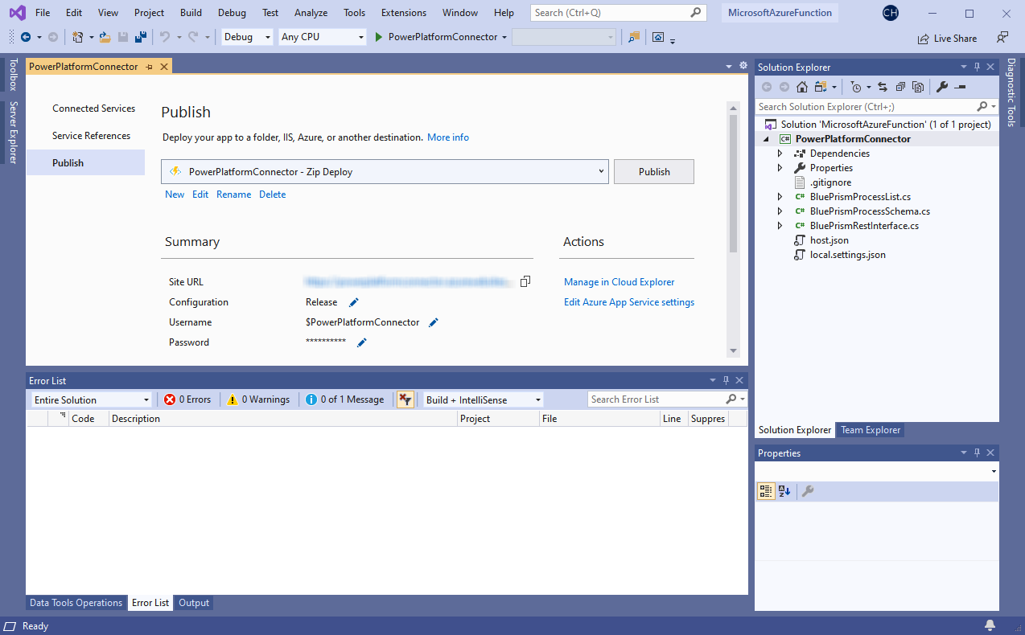

Once published to Azure, make note of the URL

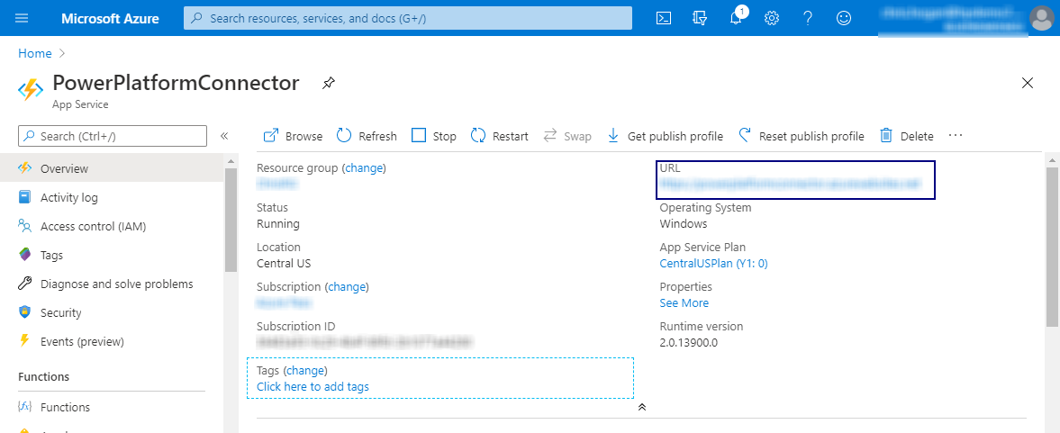

Also make note of the default App Function Key

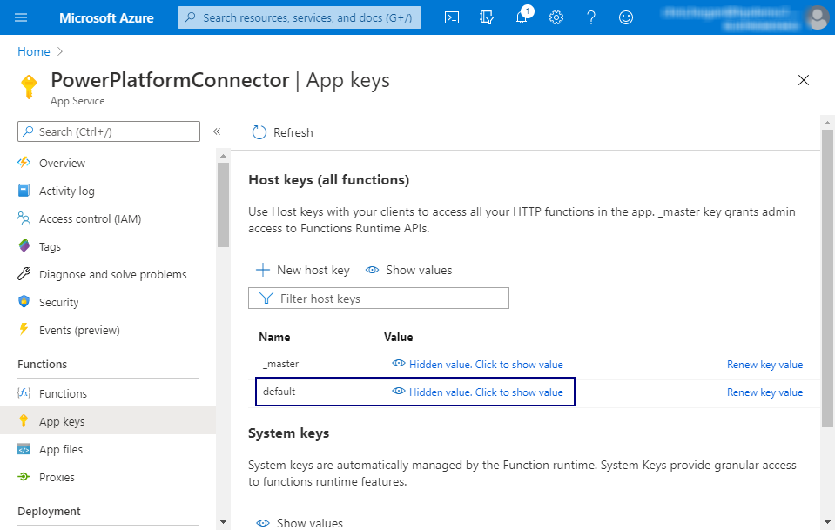

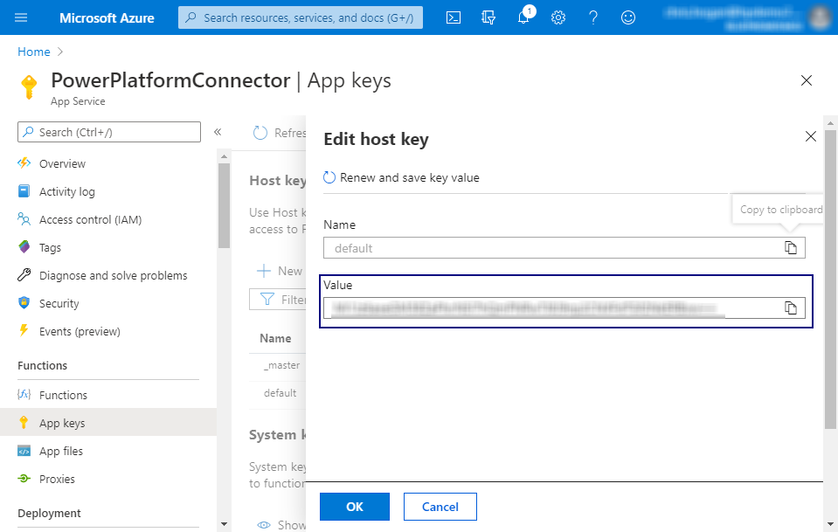

## Blue Prism Custom Connector

Import the Blue-Prism-v2.swagger.json connector definition from The Digital Exchange into Microsoft Power Automate

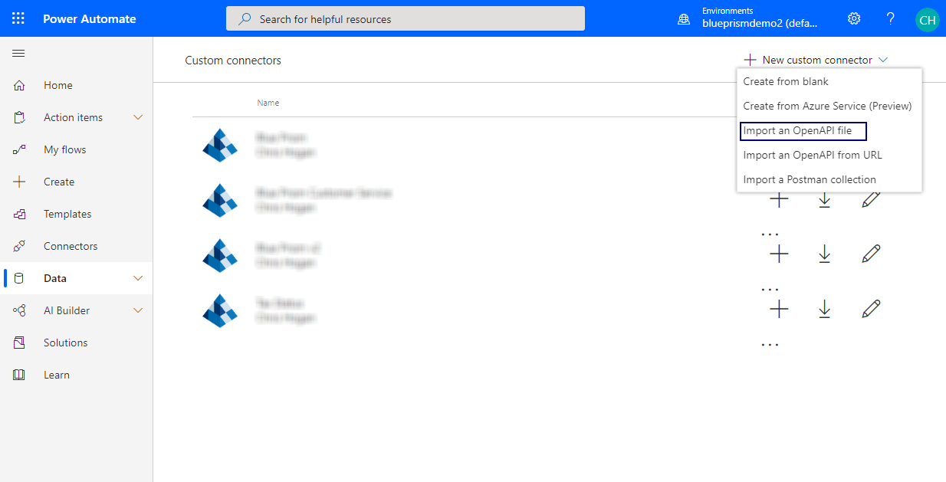

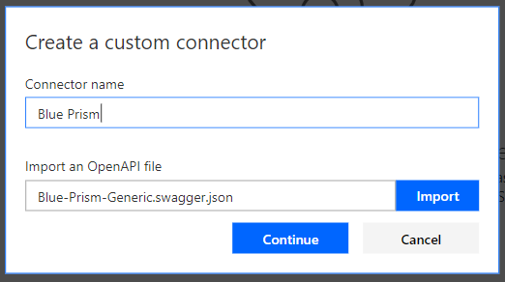

Add a custom icon if preferred, and specify the host from the Azure Function:

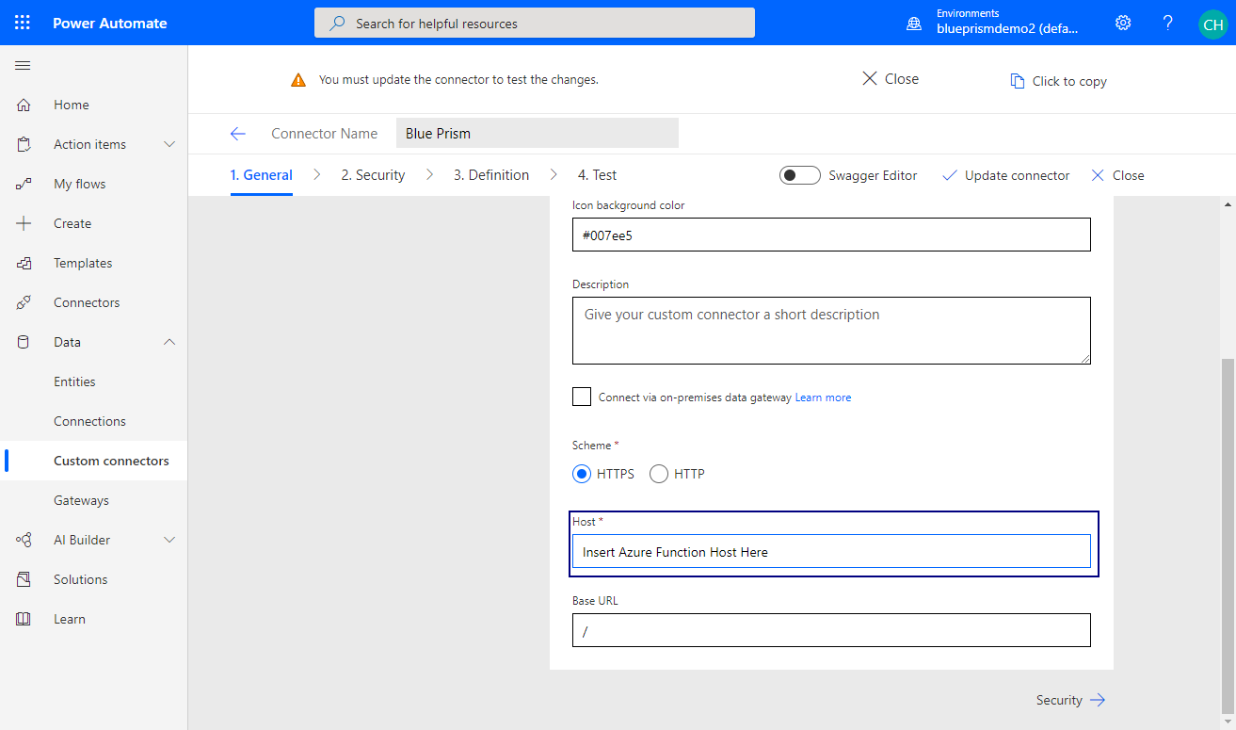

On definition tab, edit “code” and provide the Azure Function Key:

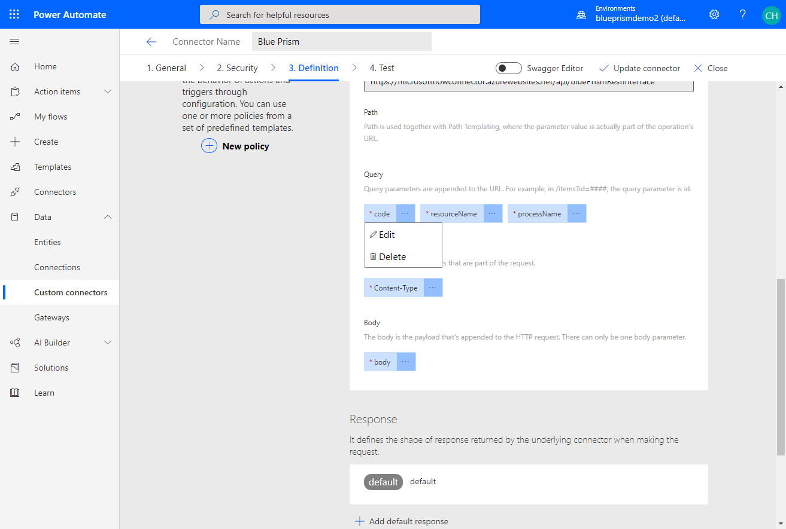

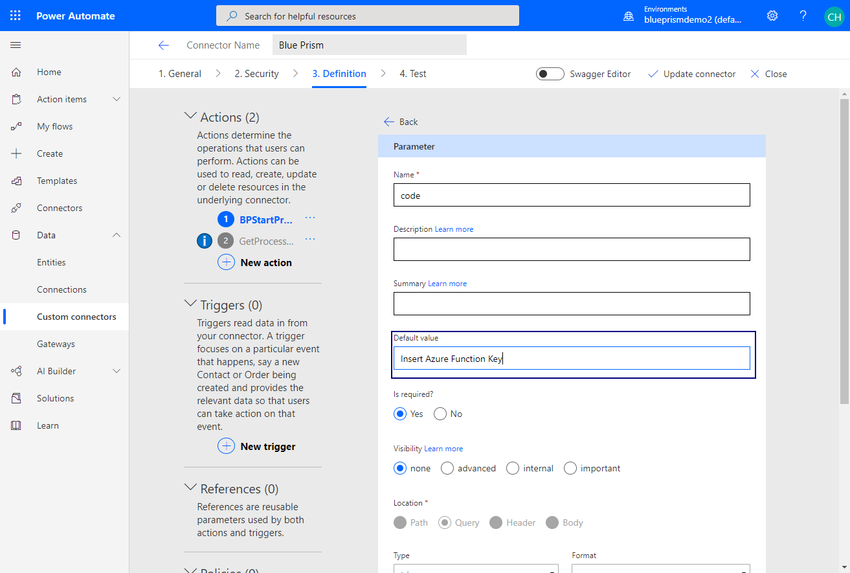

You can also provide the default values for the Resource Agent Host (and optional port number <hostname>:<port>). This can also be specified later when using the connector in a Flow.

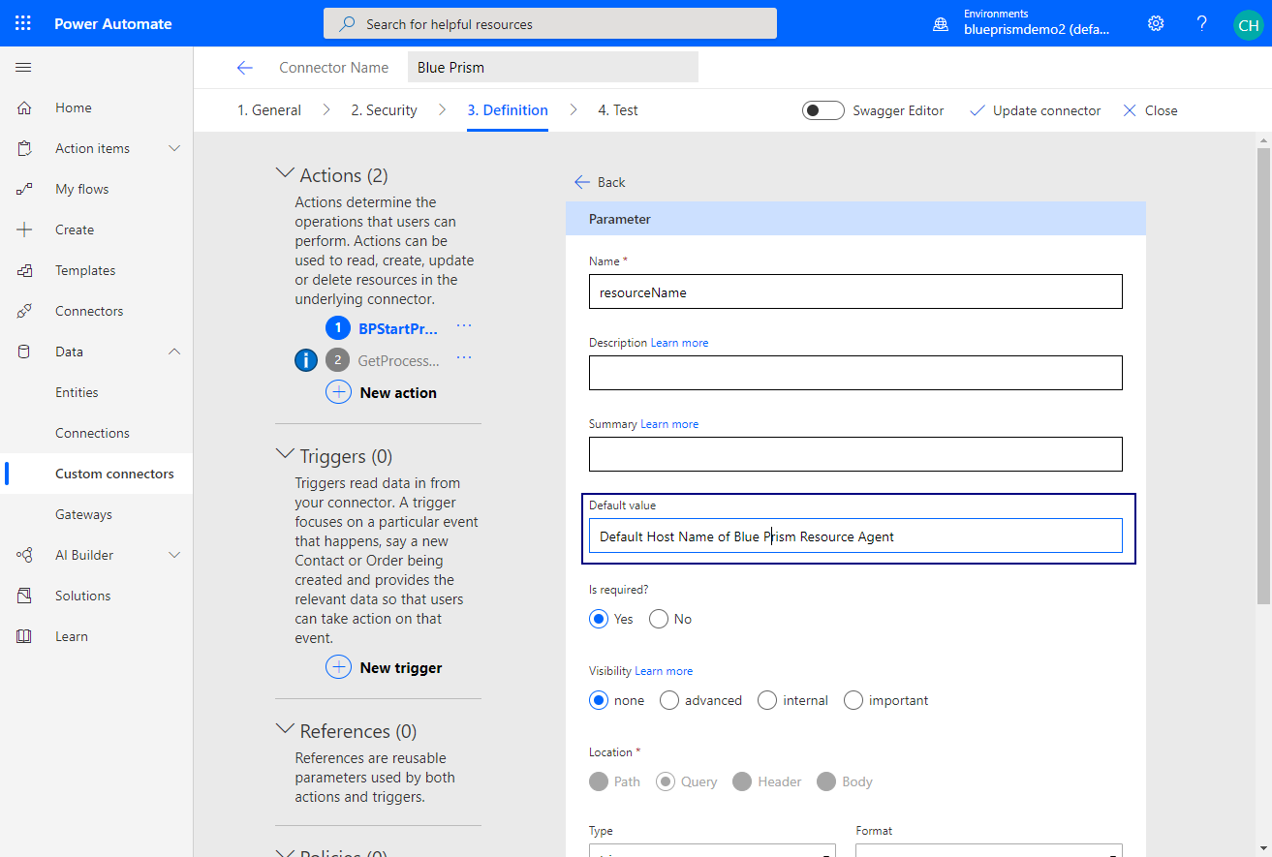

After supplying the function name host, as well as the Blue Prism Resource host, click “Update Connector” and proceed to the “Test” section.

You can test the connector by creating a connection with the credentials that Blue Prism needs

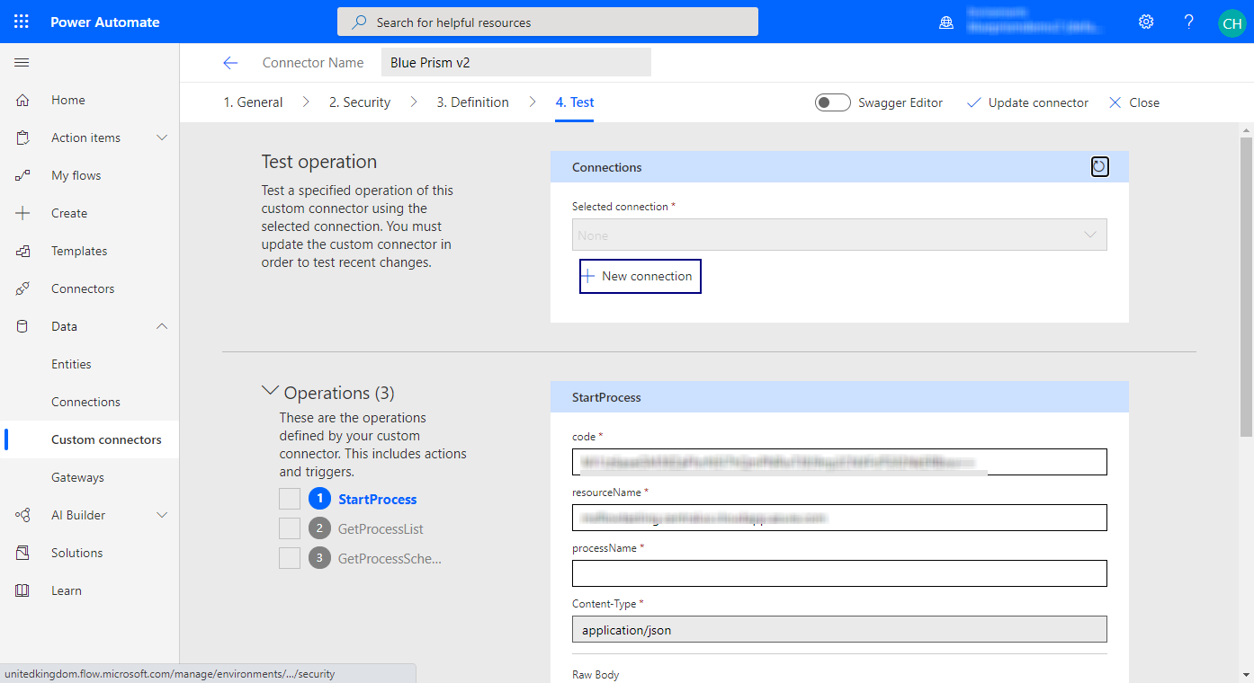

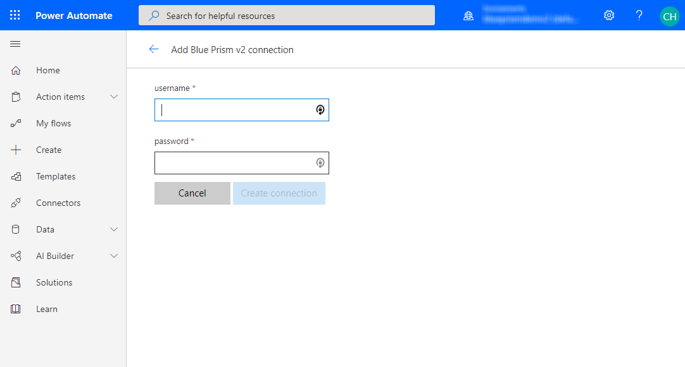

The API Code and Resource Name should be filled in. In the testing environment you will need to provide a Process name and input JSON payload. When using the connected in a Power Automate Flor, the Process Name as well in data inputs/outputs are dynamically retrieved for you.

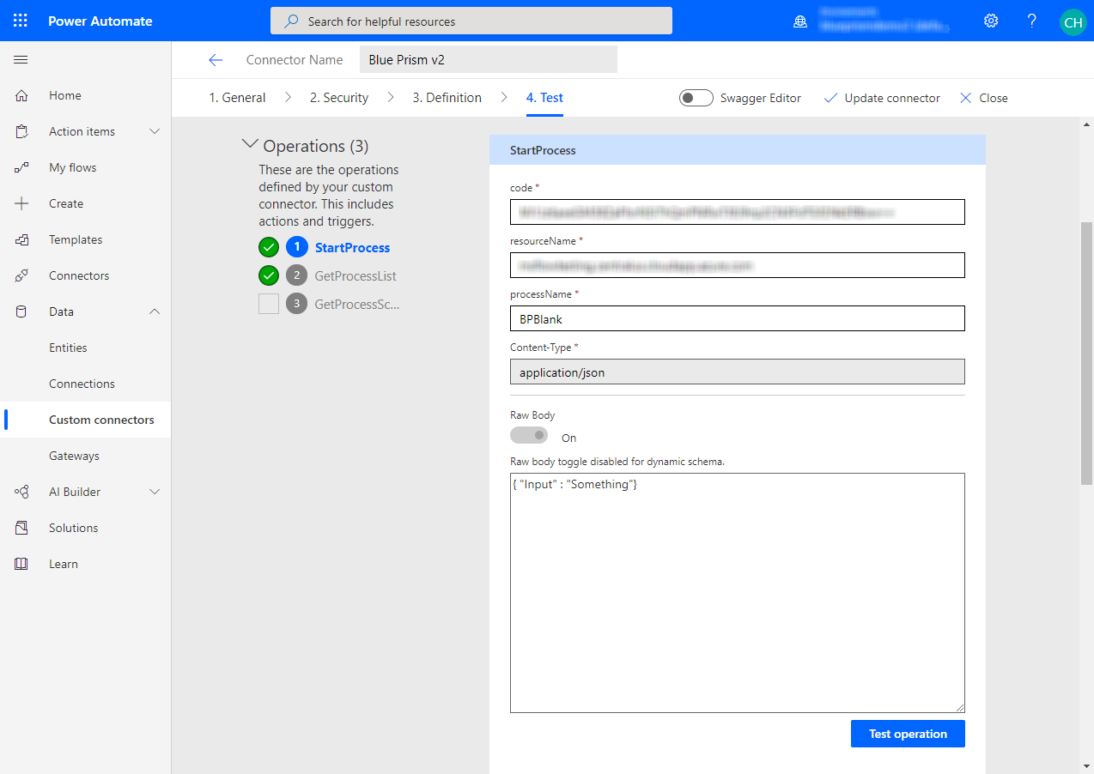

Upon completion, you will see the response that corresponds to the output of your Blue Prism Process

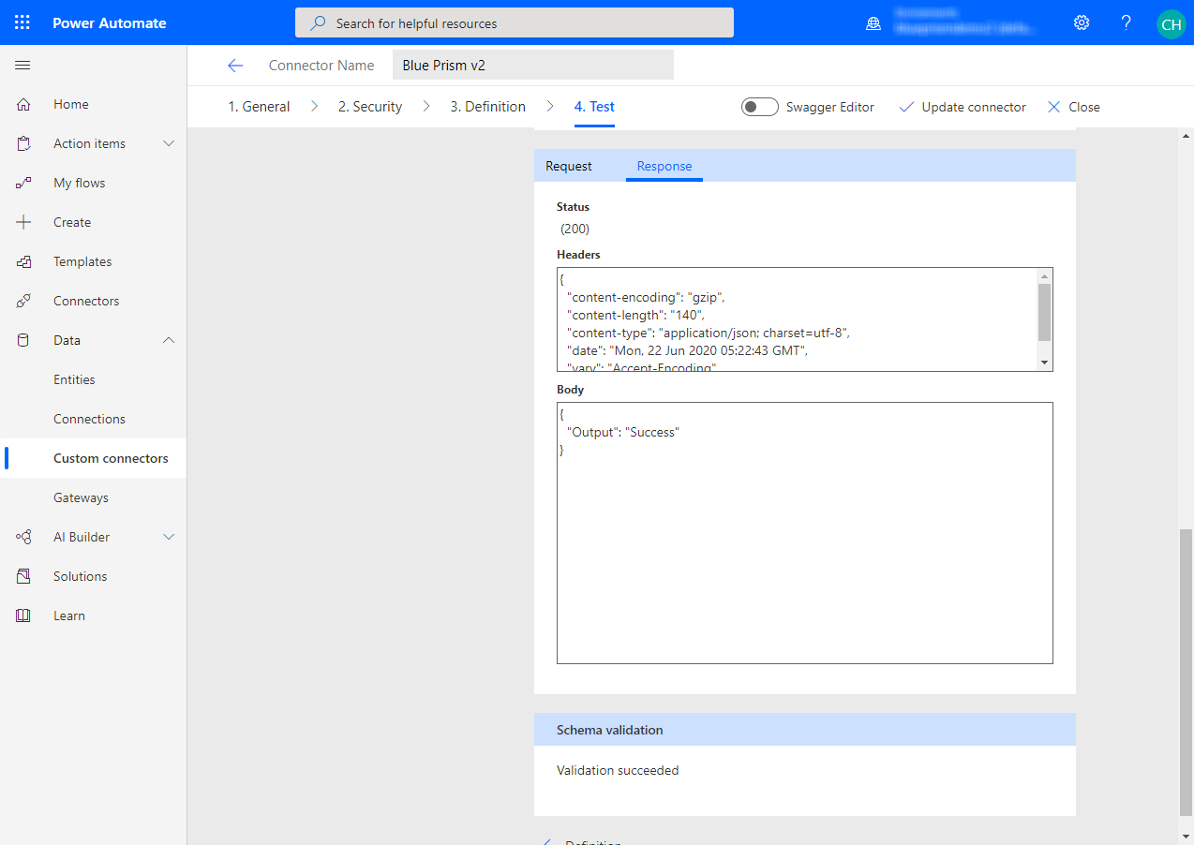

## Microsoft Power Automate Business Process

You can now create a new Flow Business Process, or add the Blue Prism Connector to an existing one

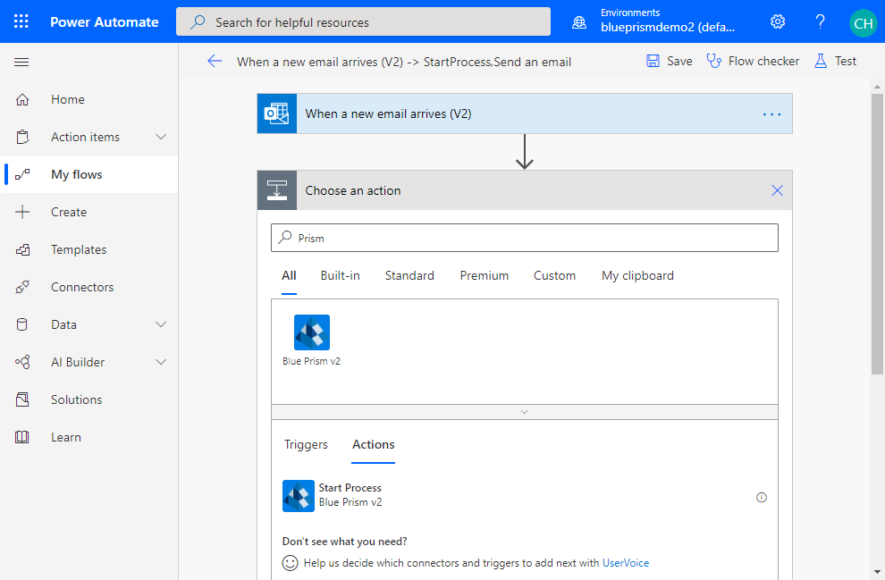

Select the Process to start from the drop down list

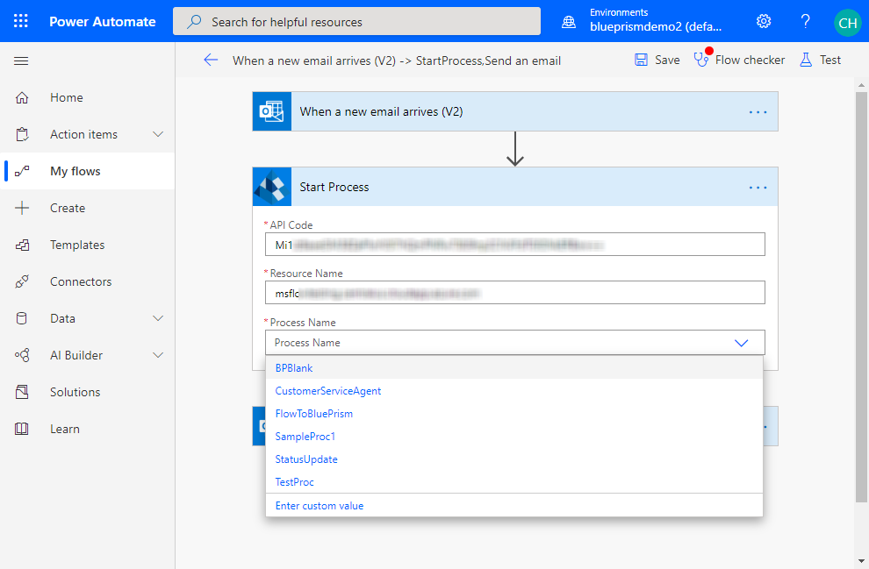

Based upon the process you select, you will be presented with the inputs needed by that process

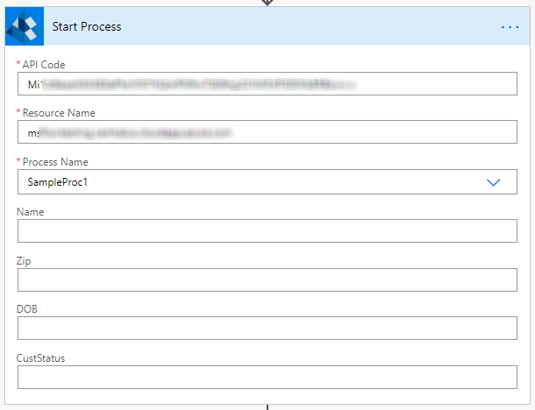

Downstream action in the Flow will be able to use the outputs from the Blue Prism process as inputs

